Week 1 Internship Report Exploratory Data Analysis (EDA) on Online Retail Dataset
Student Name: Noor Zahid

1. Objective
The objective of this task is to perform Exploratory Data Analysis (EDA) on the Online Retail II dataset. The analysis aims to understand customer purchasing behavior, identify data quality issues, discover the best-selling products, analyze sales by country, and observe revenue trends over time. The findings from this analysis will help the retail company make informed business decisions before implementing a recommendation system.

2. Dataset Description
The Online Retail II dataset contains transactional data from a UK-based online retail store covering the years 2009–2011.
The dataset includes the following information:
- Invoice Number
- Product Description
- Quantity Purchased
- Invoice Date
- Unit Price
- Customer ID
- Country

3. Tools and Libraries Used
The following tools and Python libraries were used:
- Python
- Jupyter Notebook
- Pandas
- NumPy
- Matplotlib
- Seaborn

4. Loading the Dataset
The dataset was loaded into a Pandas DataFrame using Python.
And Showing basic info and shape of the dataset.
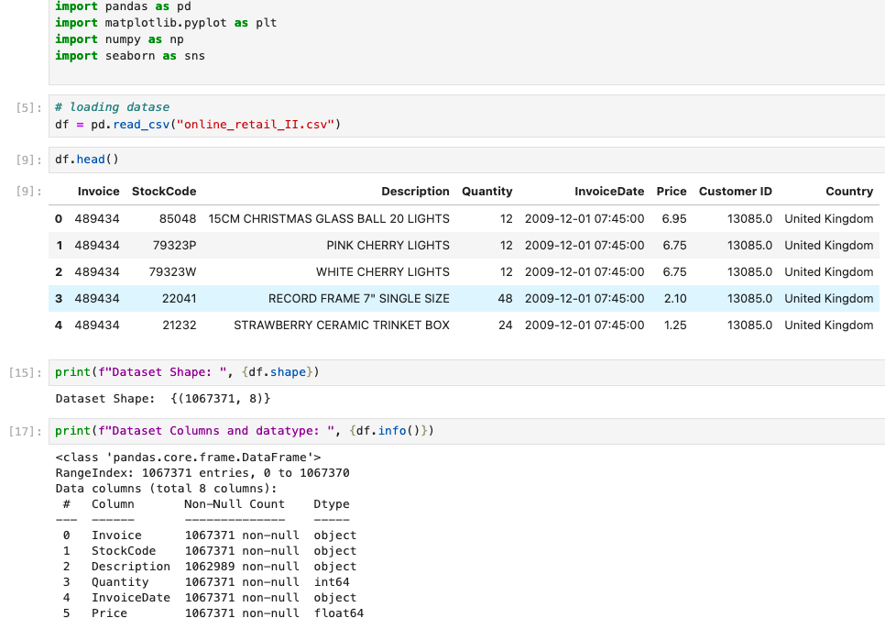

5. Missing and Duplicated Values Analysis
The dataset was checked for missing values using the isnull().sum() function.
This step helps identify incomplete records that may require attention during future preprocessing.
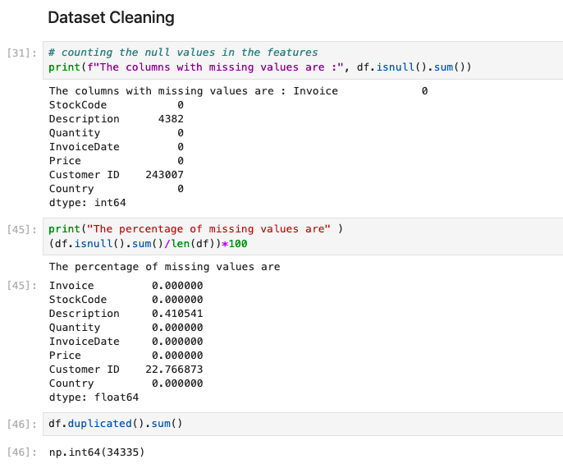

(Description and CustomerID column had some missing values)

6. Revenue Calculation
A new column named Revenue was created using the following formula:
Revenue = Quantity × Price
This column was used for revenue-based analysis throughout the project.
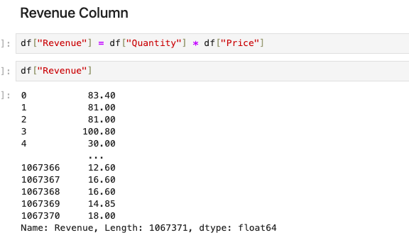

7. Top 10 Best-Selling Products by Revenue
Products were grouped according to the total revenue generated.
The highest revenue-generating products were visualized using a bar chart.

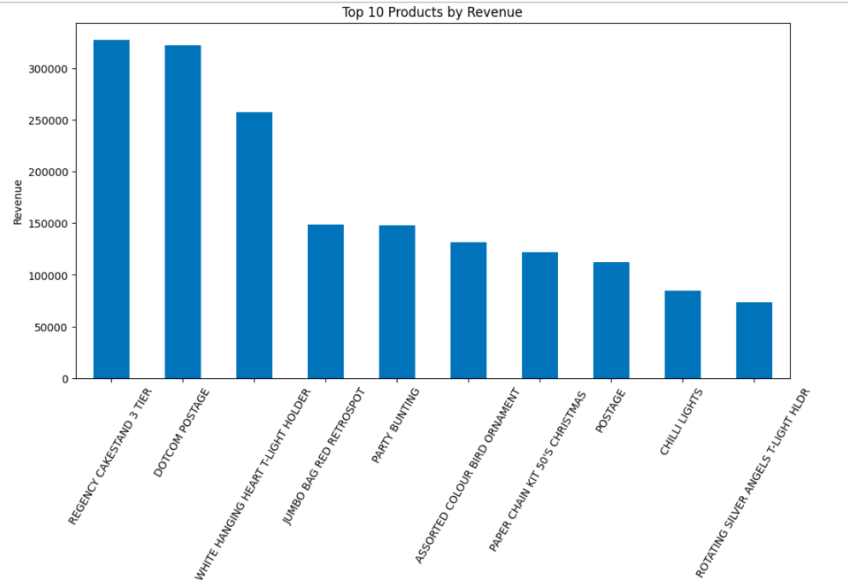

8. Top 10 Products by Quantity
Products were grouped by their descriptions, and the total quantity sold was calculated.
A bar chart was created to visualize the ten products with the highest sales volume.

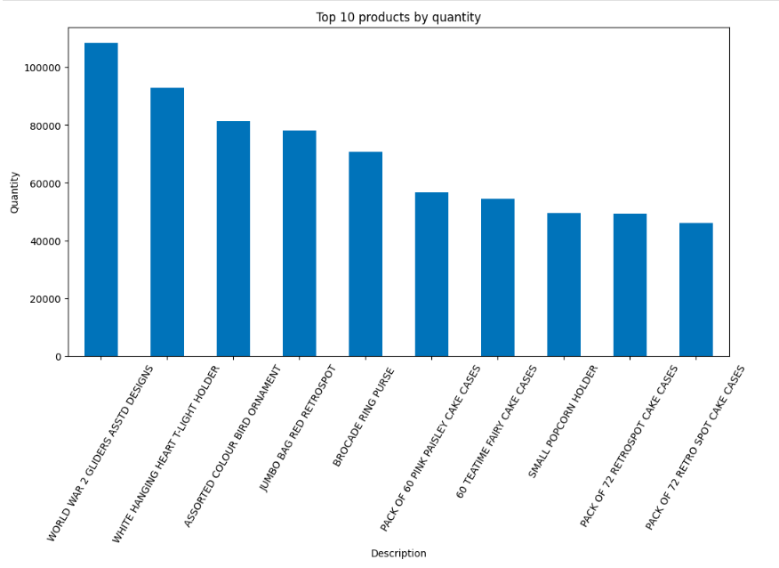

9. Sales Performance by Country
Total revenue generated by each country was calculated.
A bar chart was created to compare the countries contributing the highest sales.

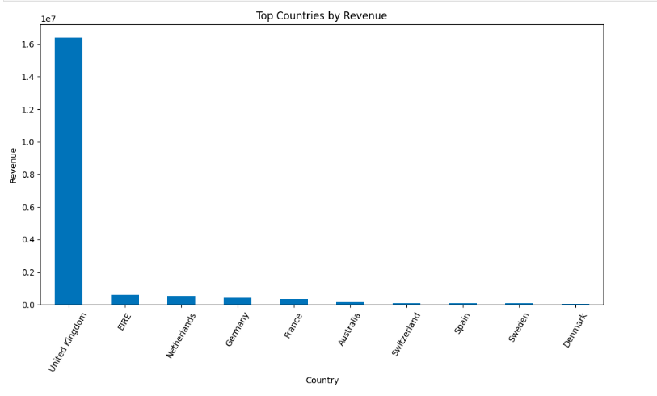

10. Monthly Revenue Trend
The Invoice Date column was converted into DateTime format.
Monthly revenue was calculated to observe sales trends over time.
A line chart was used for visualization.
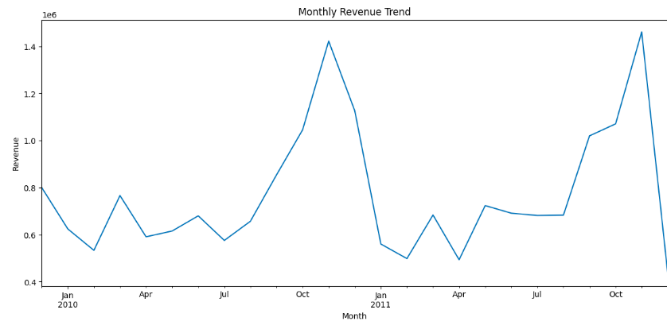

11. Correlation Analysis
A correlation matrix was generated using numerical variables.
A heatmap was created to visualize relationships among:
- Quantity
- Price
- Revenue
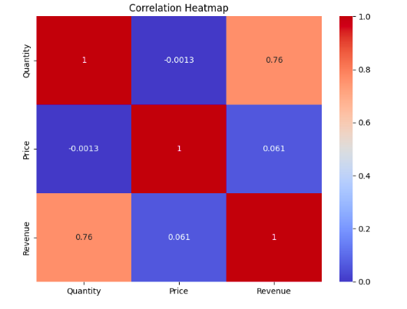

12. Outlier Detection
Box plots were created to detect outliers in:
- Quantity
- Price
- Revenue
These visualizations help identify unusually large or small transaction values.
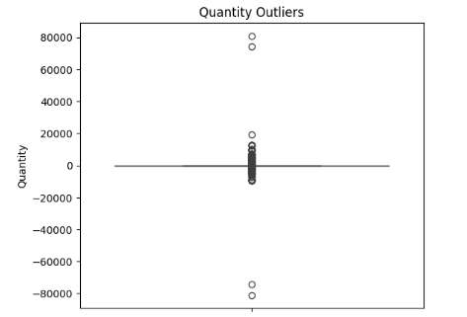
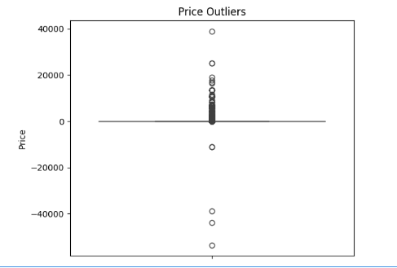

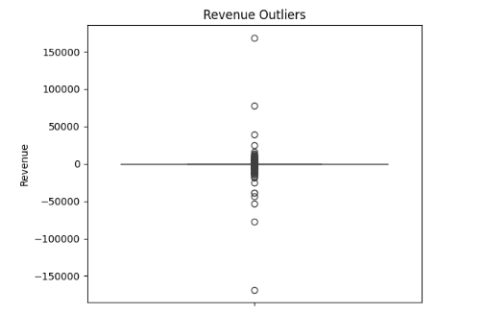

13. Business Insights
After completing the analysis, the following business insights were observed:
- The United Kingdom generated the highest overall revenue among all countries.
- A small number of products accounted for a significant portion of total sales.
- Monthly revenue showed seasonal fluctuations, indicating periods of high customer demand. October and September being the months generating highest revenue.
- The dataset contains missing Customer IDs, suggesting that some purchases were made without registered customer information.
- Several duplicate records and outliers were observed, which should be carefully handled before building predictive models or recommendation systems.

14. Conclusion
This Exploratory Data Analysis provided valuable insights into customer purchasing behavior and product performance. The analysis identified important data quality issues, highlighted the best-selling products, compared sales across different countries, and revealed revenue trends over time.
The findings from this EDA will serve as a strong foundation for future data preprocessing, feature engineering, and recommendation system development.

References
- Online Retail II Dataset (UCI Machine Learning Repository)
- Python Documentation
- Pandas Documentation
- Matplotlib Documentation
- Seaborn Documentation

